KUBERNETES ARCHITECTURE

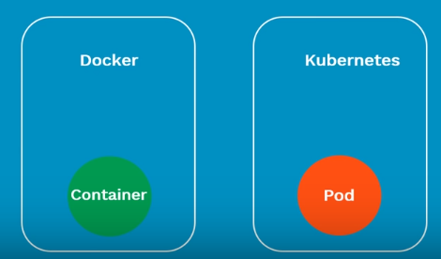

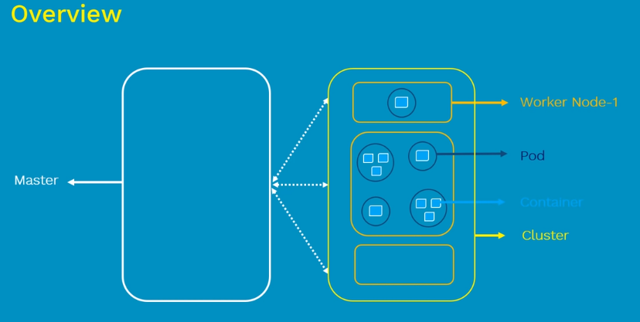

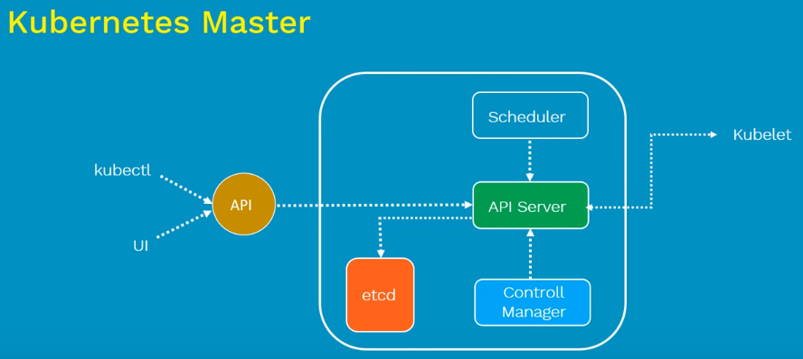

**Master :- Important components of Kb8**

Kubernetes allows 5000 worker nodes per cluster

**API Server:**

Gatekeeper for entire cluster (update,delete,create,display) objects inside kb8 cluster it has to go through the API server.

Validates and configures the api objects we submit like (pods,services,replication controllers,deployments) we interact with api server using kubectl command.

**Scheduler:-**

Responsible for physically scheduling pods across multiple nodes.

**Controller manger:**

Responsible for overall health of cluster ensures nodes inside are up and running as mentioned in sepc file

**ETCD:**

Central database to store current state of cluster at any point of time.

Cluster info nodes, secrets, controller and other object conformation is store. Any component can query of KB8 etcd to understand the state of cluster .

ETCD Single source of truth for all compo and node inside kb8 cluster.

**Worker node:**

**Kubelet:-**

It looks at the pod spec that submitted to api server and ensure that containers described in that pod spec are running successfully and healthy.

Incase if kubelet notices any issue with the pod it tryes to restart the pod on same node and incase of any issue with the node master detects the node failure and launches the pods on to another healthy node.

**Kube-proxy:-**

It is responsible for maintaining the entire network configuration.

It essentially maintains the distributed network across all the nodes pods and containers &It also exposes services, kubeproxy is core network components of kb8

**POD:**

It is basically a scheduling unit of kb8. Each pod container one or more containers

(in most cases there will be one container there are scenearios were we need to run 2 or more dependent containers together with in a pod. were one container will be helping the other )

With the help of pods we can deploy multiple dependent containers together,We primary interact with pod than containers. Each pod has uniqe ip address inside kb8 cluster

**Containers:**

It Provides run time environment for application, it will reside inside a pod, it consists of applications, libraries and their dependencies.

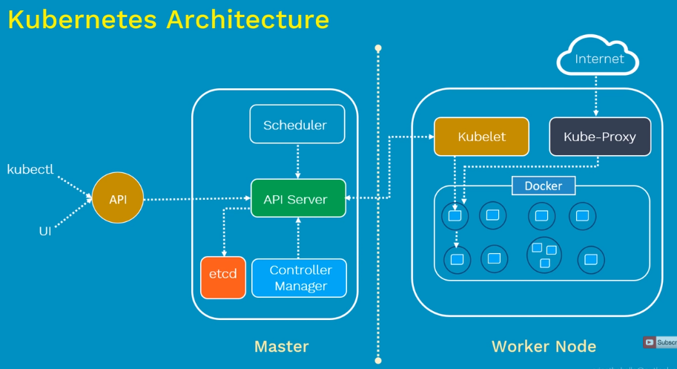

API server and scheduler components on master will decides and deploy on the worker nodes.

Containers are encapsulated as pods

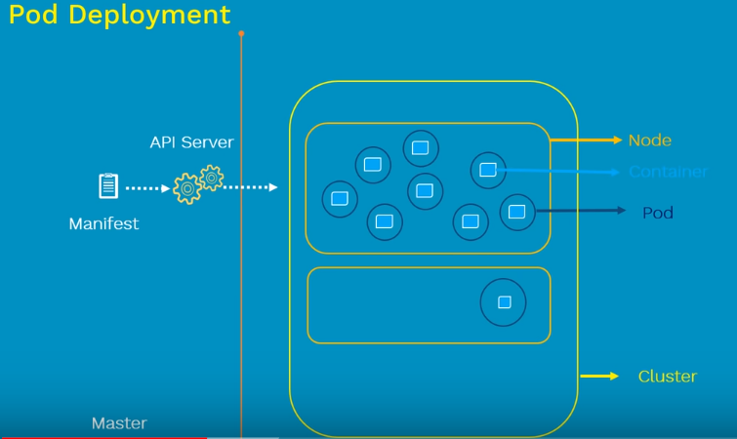

Pods can access the same ip and same mounts

